COVID DETECTION USING CHEST X-RAY

**MUFASSAL HUSSAIN CIIT/FA17-BCS-049/VHR**

**MUHAMMAD BILAL CIIT/FA17-BCS-051/VHR**



DEPARTMENT OF COMPUTER SCIENCES

COMSATS UNIVERSITY ISLAMABAD, VEHARI CAMPUS

VEHARI – PAKISTAN

SESSION 2017-2021

COVID DETECTION USING CHEST X-RAY

*Undertaken By:*

**MUFASSAL HUSSAIN**

Reg. No. CIIT/FA17-bCS-049/Vhr

**MUHAMMAD BILAL**

Reg. No. CIIT/FA17-bCS-051/Vhr

*Supervised By:*

**JAWAD RAFIQUE**



A DISSERTATION SUBMITTED AS A PARTIAL FULFILLMENT OF THE REQUIREMENTS FOR THE DEGREE OF BACHELORS IN COMPUTER SCIENCE / SOFTWARE ENGINEERING

DEPARTMENT OF COMPUTER SCIENCES

COMSATS UNIVESITY ISLAMABAD, VEHARI CAMPUS

VEHARI – PAKISTAN

SESSION 2017-2021

**CERTIFICATE OF APPROVAL**

It is to certify that the final year project of BS (CS) “Covid Detection Using Chest X-Ray” was developed by

**MUFASSAL HUSSAIN (CIIT/FA17-BCS/049)** and **MUHAMMAD BILAL**

**(CIIT/FA17-BCS-051)** under the supervision of “Jawed Rafique” and that in (their/his/her) opinion; it is fully adequate, in scope and quality for the degree of Bachelors of Science in Computer Sciences.

---------------------------------------

**Supervisor**

---------------------------------------

**External Examiner**

---------------------------------------

**Head of Department**

**(Department of Computer Science)**

**DEDICATION**

To ALMIGHTY ALLAH who serves as guidance and the source of strength and knowledge for without his guidance everything is futile. His prophet “MUHAMMAD” (peace be upon him), the most perfect and exalted among and of ever born on the surface of the earth, who is forever torch of guidance and knowledge for humanity as a whole. We feel great pleasure in expressing our heartiest gratitude to our family and our loving teachers who have supported us throughout the process. Especially lovingly dedicate this humble piece of work to our parents who serve as their inspiration, and all our classmates who always make us happy and inspired all throughout this writing

**ACKNOWLEDGEMENT**

In the name of Allah, the Most Gracious and the Most Merciful Alhamdulillah, all praises to Allah for the strengths and His blessing in completing this project. Special appreciation goes to our supervisor, **Sir Jawad Rafique** (Department of Computer Science COMSATS University Islamabad, Vehari), for his supervision and constant support, His kind behavior and attitude during period of project work is unforgettable, We express our sincere thanks to all respected teachers and faculty members of Computer Science Department of COMSATS University Islamabad, Vehari (Campus). I feel great happiness in expressing my thanks to my family for their love and support. Prayers of my family are a treasure for my life. This dissertation report is a proof of sincerity of those who helped us during this project work. So, I submit my earnest thanks again to all of them for their encouragement and moral support. Finally, we pray for health happiness and prosperity of all the participants.

**MUFASSAL HUSSAIN** **MUHAMMAD BILAL**

------------------------------- -------------------------------

**PROJECT BRIEF**

PROJECT NAME COVID DETECTION USING CHEST XRAY

ORGANIZATION NAME CUI, VEHARI

OBJECTIVE FOR DETECTION OF COVID WITHIN 10 SECONDS TO FICILITATE DOCTOR AND PATIENTS

UNDERTAKEN BY MUFASSAL HUSSAIN

MUHAMMAD BILAL

SUPERVISED BY JAWAD RAFIQUE

LECTURER

COMPUTER SCIENCE

COMSATS UNIVERSITY ISLAMABAD,

VEHARI CAMPUS

Started On 10-10-2020

Completed On 05-01-2021

COMPUTER USED HP- i3-5010U CPU

ACER-A9-9420

SOURCE LANGUAGE PYTHON 3.7

DART 2.0

OPERATING SYSTEM WINDOWS 10

TOOLS USED JUPYTER NOTEBOOK

FLUTTER

VISUAL STUDIO CODE

ANDROID STUDIO**ABSTRACT**

COVID-19 Detection Using Chest X-Ray is a Machine learning based prediction model trained with deep learning model on the dataset of COVID-19 Positive patient’s chest X-Ray Images, Other disease patients chest X-Ray Images, and Normal patient’s chest X-Ray Images. This model is used for predicting COVID-19 presence in the Chest X-Ray Images of patients using the training on previous patient’s dataset. This model is used in Website (Using Flask Python), Android application and iOS application (Using Flutter). The patients can easily upload their Chest X-Ray Images through Web, Android app or iOS app and can predict the presence of COVID in the X-Ray Image. The model will show the result as COVID positive for those whose X-Ray Images match the dataset of COVID Positive patients X-Ray images, COVID Negative for those whose X-Ray Images match the dataset of normal patients X-Ray images and other disease for those whose X-Ray Image matches the dataset of other disease chest X-Ray Images.

………………………………………………Contents………………….--

LIST OF FIGURES x

LIST OF TABLES xi

1 INTRODUCTION 1

1.1 System Introduction 1

1.2 Background of the System 2

1.3 Objectives of the System 3

1.4 Significance of the System 4

2 REQUIREMENT SPECIFICATIONS 4

2.1 Product Scope 4

2.2 Product Description 5

2.2.1 Product Perspective 5

2.2.2 Product Functionality 5

2.2.3 Users and Characteristics 6

2.2.4 Operating Environment 6

2.3 Specific Requirements 6

2.3.1 Functional Requirements 6

2.3.2 Behavioural Requirements 7

2.3.3 External Interface Requirements 8

2.4 Non-functional Requirements 12

2.4.1 Performance Requirements 12

2.4.2 Safety and Security Requirements 13

2.4.3 Software Quality Attributes 13

3 DESIGN SPECIFICATIONS 14

3.1 Introduction 14

3.2 Composite Viewpoint 14

3.3 Logical Viewpoint 15

3.4 Information Viewpoint 15

3.5 Interaction Viewpoint 16

3.6 State Dynamics Viewpoint 17

3.7 Algorithmic Viewpoint 18

4 DEVELOPMENT AND TOOLS 18

4.1 Introduction 18

4.2 Development Plan 18

4.3 Development Tools 19

4.4 Conclusion and Future Work/Extensions 19

5 QUALITY ASSURANCE 20

5.1 Introduction 20

5.2 Traceability Matrix 20

5.3 Test Plan 21

6 USER MANUAL 22

6.1 Introduction 22

6.2 Hardware/Software Requirements for the System 23

6.3 Installation guide for Application 23

6.4 Operating Manual 23

# LIST OF FIGURES

Figure 2.1: Productive Perspective 5

Figure 2.2: Behavioral Requirements 7

Figure 2.3: Home Page Web Application 8

Figure 2.4 Contact Us Page Web Application 8

Figure 2.5: Covid Detection Page Web Application 9

Figure 2.6: Covid Detection Web Application 9

Figure 2.7: Covid Detection Page3 (Result as Covid Negative) 10

Figure 2.8: Covid detection page 4 (Result as Covid Positive) 10

Figure 2.9: Symptoms Page Mobile App 11

Figure 2.10: Do's & Don’t Do's Page Mobile App 11

Figure 2.11: Main Page Mobile App 11

Figure 2.12: Positive Result Mobile App 11

Figure 2.13: Predict Page Mobile App 11

Figure 2.14: Splash Page Mobile App 11

Figure 2.15: Other Disease Result Mobile App 12

Figure 2.16: Normal Result Mobile App 12

Figure 3.1: Package Diagram for Web Application 14

Figure 3.2: Package Diagram for Mobile Application 14

Figure 3.3: Class Diagram for Web Application 15

Figure 3.4: Class Diagram for Mobile Application 15

Figure 3.5: Sequence Diagram for Web Application 16

Figure 3.6: Sequence Diagram for Mobile Application 16

Figure 3.7: UML State Machine Diagram for Web Application 17

Figure 3.8: UML State Machine Diagram for Mobile Application 17

Figure 4.1: Gantt chart 19

# LIST OF TABLES

Table 1.1: Related System Analysis with proposed project solution 2

Table 4.1: Tools and Technologies for Proposed Project 19

Table 5.1: Traceability Matrix 20

Table 5.2: Test case for web Application start up 21

Table 5.3: Test case for Covid Prediction Through Website. 21

Table 5.4: Test case for Mobile Application start up 22

Table 5.5: Test case for Covid Prediction through Mobile Application 22

# INTRODUCTION

In Chapter 1, we will discuss about the Brief system Introduction of “COVID- 19 detection using chest X-Ray”. We will discuss the details of the system as well as the functionalities and process of Implementation of this project.

Moreover, we will also discuss about the background of this project, how we need this project as well as how we implement our idea in this project. We will also discuss the previous similar projects to “COVID- 19 detection using chest X-Ray”, how this project overcome the problems and errors in the previous systems and how this project is better than others.

We will also discuss the objectives of “COVID- 19 detection using chest X-Ray” what should be its output and what the functionalities we used in this project are. We will specify the major objectives for this system.

In addition, we will also discuss about the significance of this system where it can be applied and what would be its importance in the coming time.

## System Introduction

‘COVID-19 prediction using chest X-rays’ is a Machine learning Model that detect the Corona Virus using chest X-rays of Patients. In this Model we will be able to predict the presence of corona virus in the patients using their chest X-Ray. This model will be trained on the dataset of chest X-rays of Corona positive Patients and the chest X-rays of Normal person. We will use the model of CNN to train our model. In which we collect the X-Ray images of the patient’s chest X-rays patients and Normal person, so that the Model will be able to predict the Corona presence in the X-ray report.

In previous days when the COVID-19 came to Pakistan the doctors have no way to test it. There is no testing machine for detecting COVID-19 virus when it first occurs in Pakistan. The doctors in Pakistan use the same approach for detecting Corona virus in patient by using their Chest X-Rays and the symptoms that the patient tells the doctor. We are thinking when the human doctor can predict Corona virus using their Chest X-Rays and the symptoms why shouldn’t machine do it? What if we give the knowledge that doctor use to detect corona virus to the machine and machine start predicting it itself? While the Human doctor can predict it than the machine will definitely predict it accurately. So, we decide to develop a Machine Learning AI based Model that will be trained on the dataset that like the doctors are used to detect it by seeing the previous X-Rays of Corona positive patient and compare the new one with the previous knowledge and observe that whether the patient have the COVID-19 in their body or not. The Model will work same as a doctor as Model will collect knowledge from previous dataset of corona positive patients, in computer language the Model will be trained on the previous dataset of Corona virus positive patients chest X-Rays and the normal persons chest X-Rays.

After it completes their training on that Dataset of Corona positive patient’s chest X-Rays and the chest X-Rays of Normal peoples, we will be able to detect the presence of corona virus in patient using their chest X-ray report. We provide the chest X-ray image of patient to the Model so that it can predict the presence of Corona virus in patient within few second by using their previous training on the chest X-rays of Corona positive Patients and chest X-rays of Normal peoples. It will give report in Corona Positive, Corona negative or Other Disease. And if Corona positive it also shows the infection condition in their lung in percentage.

It later can be used on public sectors because of its rapid detection/prediction of Corona patient by using their X-Rays. It also can be used on the places where those days corona test is required to enter like airports, they ask the passenger for fresh corona test before start their journey while it causes a long delay in their flights.

## Background of the System

Table 1.1: Related System Analysis with proposed project solution

|  |  |  |
| --- | --- | --- |
| **Application Name** | **Weakness** | **Proposed Project Solution** |
| **‘Health-Discernment-System’** | One major problem in this application is not having high-accuracy deep learning algorithms for disease detection and the lack of large imaging datasets for training.  Due to the lack of a sufficient dataset, training a deep learning-based model for medical diagnosis related problems is computationally expensive, and the results achieved are also not up to the mark. | The working can be stated as follows:   1. The Large dataset of chest X-Rays images of Corona patients and Normal Persons 2. The Model will be trained very accurately using the CNN Algorithm. 3. After that when the Model is trained it will work according to CNN algorithm as it classifies the new patients X-Ray image as a radiography with the radio images on which they trained |

**Advantages/Benefits of Proposed system:**

* + Time safety.
  + Prevent spread of corona virus minimum 50%.
  + Will be very beneficial for the patients.
  + Will save many lives from death that will cause by late testing or by not giving first aid due to not diagnosed.
  + People will be more aware of their present condition due to COVID-19.
  + Will encourage the peoples for test, who didn’t test because of their time consumption and the Cost of test.

## Objectives of the System

* **Collection of Dataset**

In this study, chest X-ray images of COVID-19 patients have been obtained from the open-source Github repository. This repository is containing chest X-rays images of mainly patients. In addition, 4600 chest X-ray images include Positive and Negative COVID-19 X-ray and Other Disease.

* **Image Pre-processing**

One of the significant phases in the data preprocessing was to resize the X‐Ray images as the image input for algorithm were different. We implemented some image pre-processing technique to increase the performance to our system by speeding up training time.

* **Transfer Learning:**

Transfer learning is a machine learning technique which is based on the concept of reusability which is trained for the specific problem. Labeling data by experts is both costly and time consuming. The biggest advantage of using transfer learning method is that it allows the training of data with fewer datasets and requires less calculation costs. With the transfer learning method, which is widely used in the field of deep learning, the information gained by the pre-trained model on a large dataset is transferred to the model to be trained.

* Use the feature extraction section of the convolution neural network.
* **Tensor Flow and Keras**

It is an artificial neural network there are more than three layers, has single input, single output and many invisible layers. To use transfer learning for classifying chest X-ray images, we used the Tensor Flow library to load the CNN model on our local machine, retrain it on the chest X‐ray dataset and then classify new images to be one of the two categories normal, and COVID‐19. It is a deep learning framework established by Google that can control all neurons (nodes) in the system and has a library appropriate for image processing. Neural network weights can be changed to improve performance.

Keras is the high-level API of Tensor Flow: an approachable, highly-productive interface for solving machine learning problems, with a focus on modern deep learning

* **User Interface**

We are developing web base application for this in which user upload image and then after performing operation it shows result covid-19 positive or negative

## Significance of the System

“COVID-19 prediction using chest X-rays” is the solution. It is AI Model that predicts the presence of COVID-19 Virus by just using the chest X-ray of the patient. No need to wait for any more as the regular Corona test requires 1 day this Model will requires 10-20 Seconds to predict the presence of Corona virus in the Chest X-ray by using its previous training on the Dataset of Corona positive patient’s Chest X-rays and the Normal person’s chest X-rays and Other Disease Chest X-rays. All we need is X-ray of the patient who came for test of COVID-19. We insert the X-ray image to the trained model and the model will predict that the patient has Corona virus it Compare with its previous training on the dataset to predict whether the patient have the Corona virus or not.

In this project first we collect dataset and perform image augmentation and Image Preprocessing after performing these operations we apply CCN model for classification and prediction of COVID-19. DCNN typically perform better with a larger dataset than a smaller one. Transfer learning can be beneficial in those applications of CNN where the dataset is not large. The idea of transfer learning uses the trained model from large datasets such as is used for application with comparatively smaller dataset. This eliminates the requirement of having large dataset and also reduces the long training period as is required by the deep learning algorithm when developed from scratch.

# REQUIREMENT SPECIFICATIONS

Software Requirement Specification (SRS) specify all the software requirements for our project. In this chapter we will study scope, project description and specify all the functional and non-function requirements for our project.

## Product Scope

This system will help to predict the presence of COVID-19 in chest X-RAY of patient efficiently. In this predicting system, we will provide a user-friendly interface that can be used by the users to detect whether their COVID-19 test results are positive or normal, i.e., it will take X-RAY image as input from user and after detection It will provide a result of prediction as COVID positive, COVID negative or other disease. This will ultimately help the patients to save time as they won’t have to run to the doctor just to know what their X-RAY reports say about COVID. In case the test results are COVID negative, it will greatly help the patient to save money, as there won’t be any requirement to visit the doctor again. Decisions are often made based on the doctor’s intuition and experience and sometimes that may not be completely correct. In this interface the predictions will be free of unwanted biases and errors- so it will be completely trust worthy. The doctors can also use this system to predict the COVID presence results better. The lab technicians and the other health-care professionals can also use this predicting system to guide the people.

## Product Description

### Product Perspective

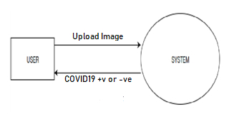COVID-19 prediction using chest X-rays’ is a Machine learning Model that detect the Corona Virus using chest X-rays of Patients. In this Model we will be able to predict the presence of corona virus in the patients using their chest X-Ray. This model will be trained on the dataset of chest X-rays of Corona positive Patients and the chest X-rays of Normal person. We will use the model of CNN to train our model. In which we collect the radio graphic images of the patient’s chest X-rays patients and Normal person, so that the Model will be able to predict the Corona presence in the X-ray report.

Figure 2.1: Productive Perspective

### Product Functionality

System will read the image uploaded by the user, augment it and will use the saved custom model to detect whether the disease is present or not in the patient and thus display the result in a user-friendly language.

Below are the steps:

* Upload Image: The user can easily upload the X-RAY test report image through a Web UI, Android app or IOS app. The image should be in jpeg, png or jpg format
* Read Image: The image will be scanned before preprocessing takes place.
* Transform Image: The scanned image is then transformed into a format that is needed by the saved custom model. It would be transfer into grey scale image.
* Evaluate image using saved model: The saved custom model creates a feature map of the uploaded X-RAY image and predicts the output.
* Determine and Analyze the Output: The predicted output is then analyzed and converted to a user-friendly language.
* Display the Output: The analyzed result is then displayed to the user through web, android or IOS UI as COVID negative, COVID positive or other disease.

### Users and Characteristics

The COVID-19 detection using chest X-RAY System has one active actor (patients along with healthcare professionals) and one cooperating system at the back end. The patients and health-care professionals like doctors and interns can access the system through a Web Application, Android App or IOS App for detecting COVID-19 presence in chest X-RAY.

### Operating Environment

* **Web Application**

We are using flask python for web UI which can be operate on any web browser. User can access the web from desktop web browser or any other web browser from any device.

* **Mobile Application**

We use flutter to implement our project on android and iOS. User can access the mobile application from any android device (Tablet/mobile) or any iOS device (iPhone/ iPad).

## Specific Requirements

### Functional Requirements

Functional requirements are the core requirements of a software, it includes how the program works, How the data is manipulating and processing and how the result shows, that defines what the system is supposed to achieve. The functional requirements also help the developers and designers to design and program the software to complete all the requirements and also help to validate the system according to those functional requirements, to verify the system works according to the requirements or not, It also states that the system is reliable or not.

So, those functional requirements of this system are as following:

* **User Input:**

System will be able to take input from user. User will be able to input data to the system.

* **Dataset:**

Dataset contains the Chest X-Ray images of COVID positive and COVID Negative patients.

* **Preprocessing:**

System will preprocess each image of dataset according to algorithm used and extract features from dataset images. It also preprocesses the input Chest X-Ray image from user before applying classification.

* **Detection of COVID:**

System will be able to detect COVID presence in patient using their chest X-Ray Image.

* **Classification:**

System will classify the dataset into two as COVID positive and COVID negative classification. System will be able to classify the input image according to the previous training on database. It classifies the image as COVID positive and COVID negative.

* **Accuracy:**

System will be able to generate the accuracy rate of the classification between 1 and 0. 1 considered as best case and 0 as worst. So, it shows in result to improve the reliability of the result as it shows the accuracy of the result as well as the classification result.

### Behavioural Requirements

Figure 2.2: Behavioral Requirements

### External Interface Requirements

#### Web Application User Interface

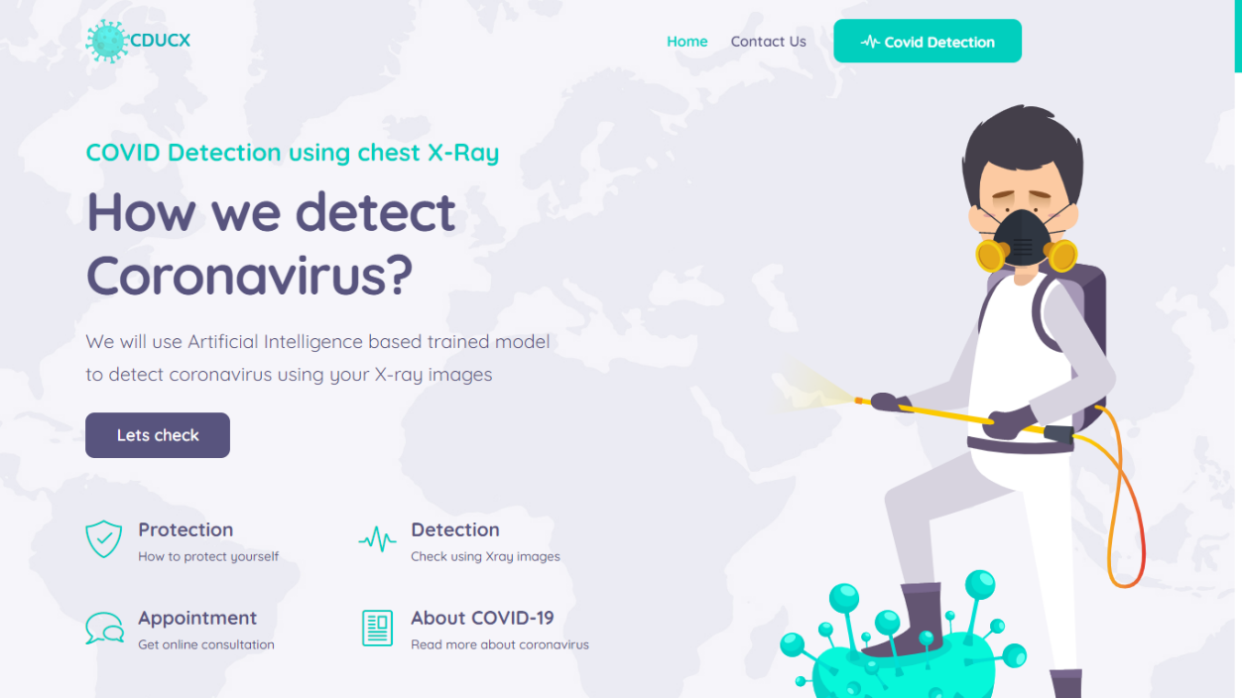

Figure 2.3: Home Page Web Application

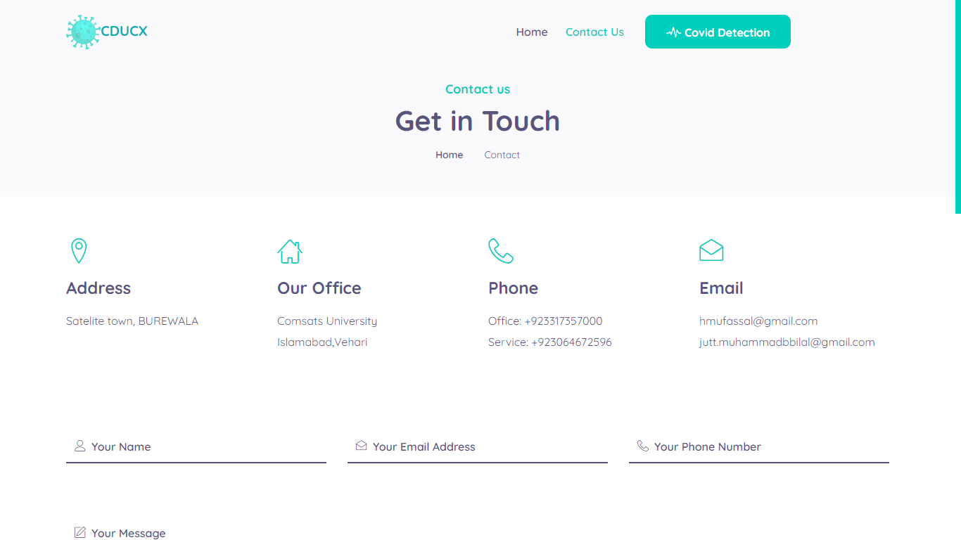

Figure 2.4 Contact Us Page Web Application

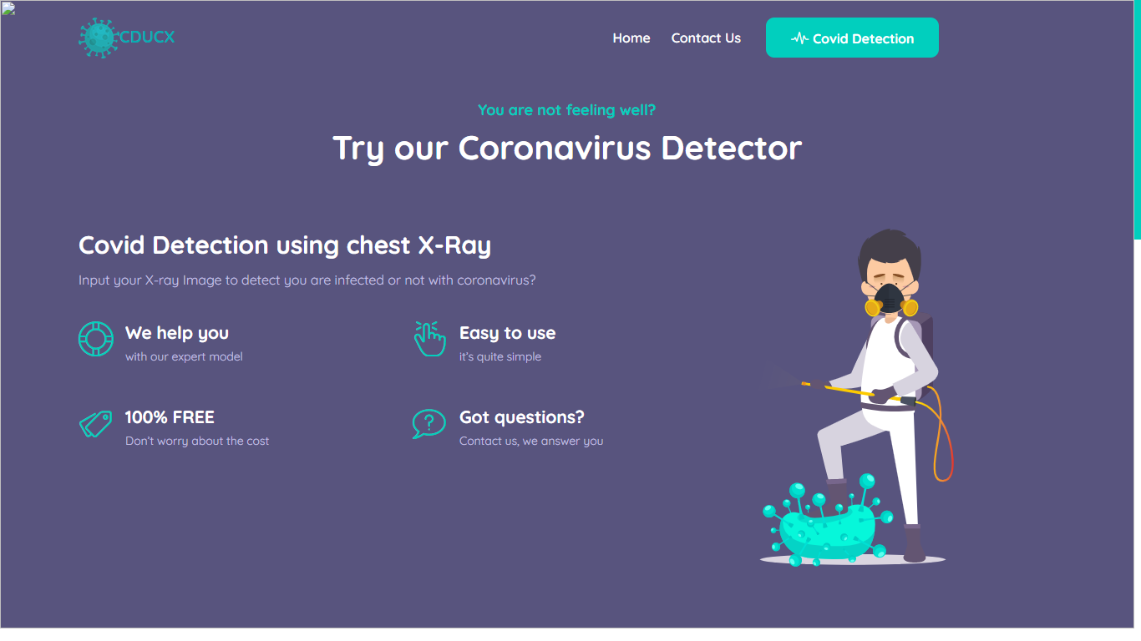

Figure 2.5: Covid Detection Page Web Application

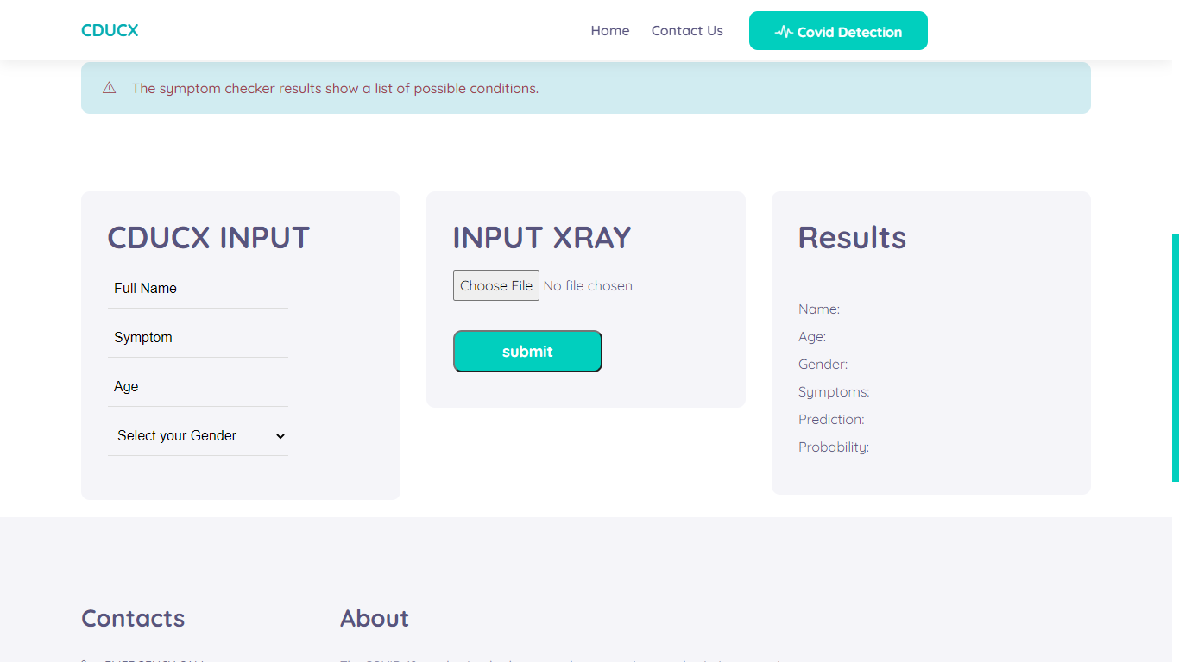

Figure 2.6: Covid Detection Web Application

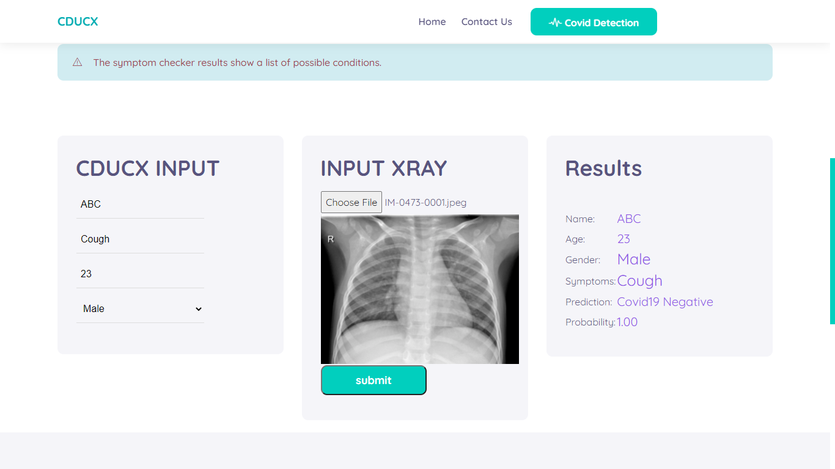

Figure 2.7: Covid Detection Page3 (Result as Covid Negative)

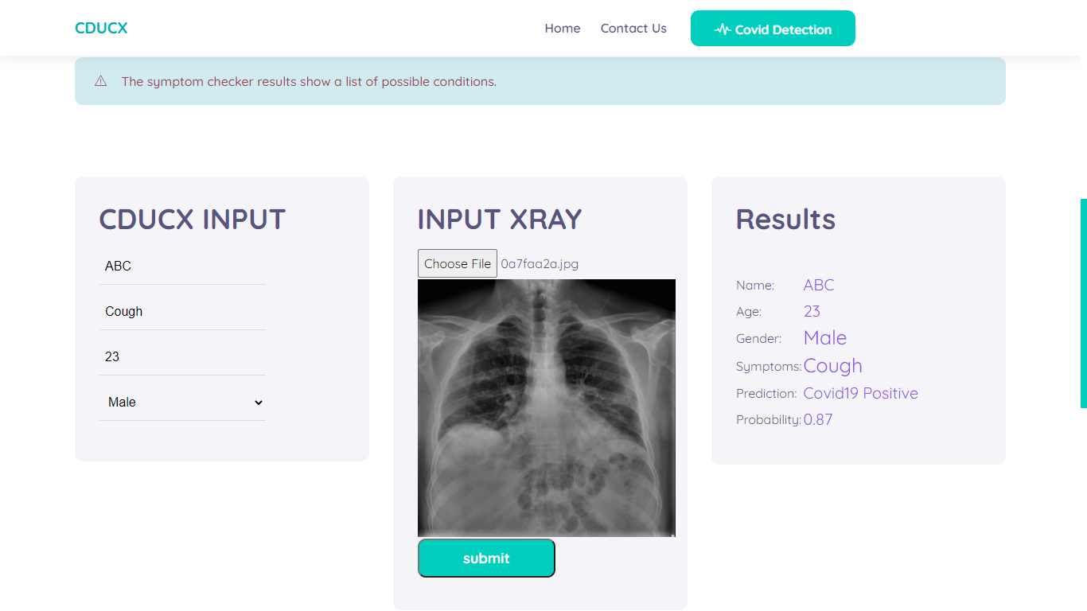

Figure 2.8: Covid detection page 4 (Result as Covid Positive)

#### Mobile Application User Interface

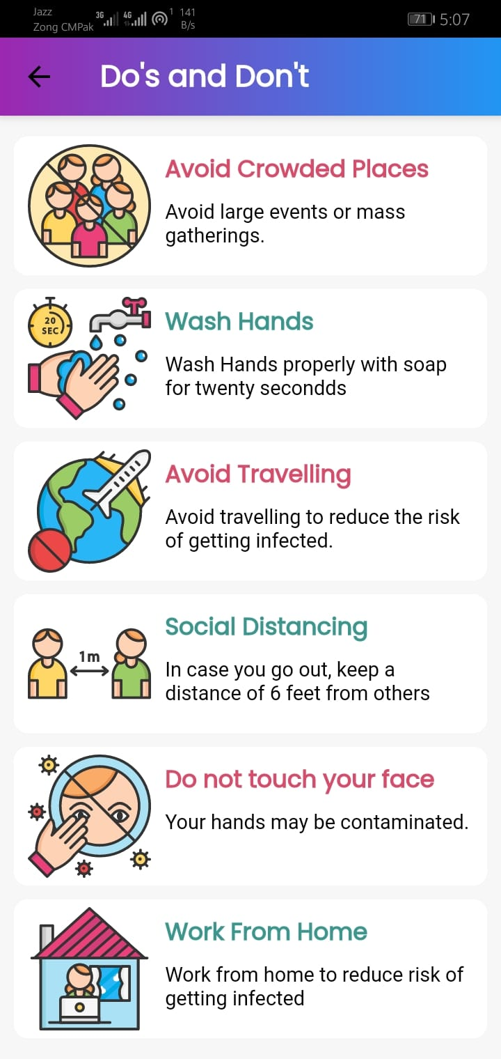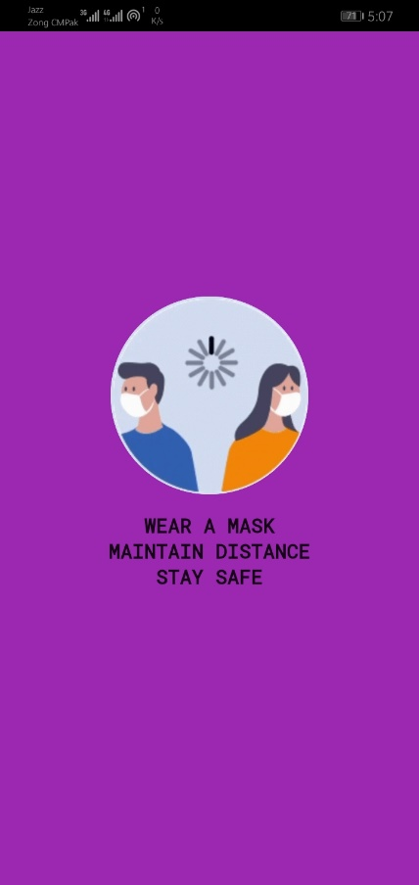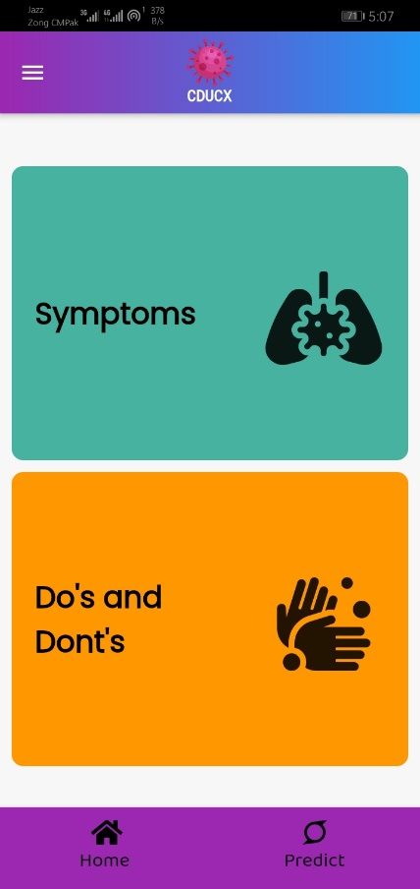

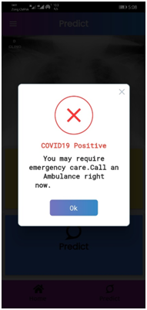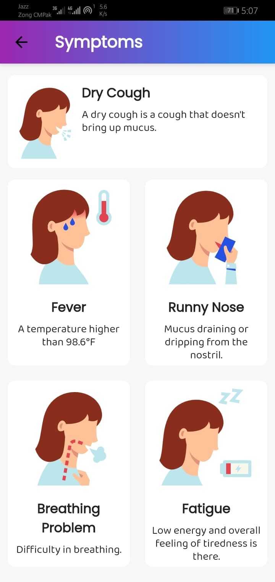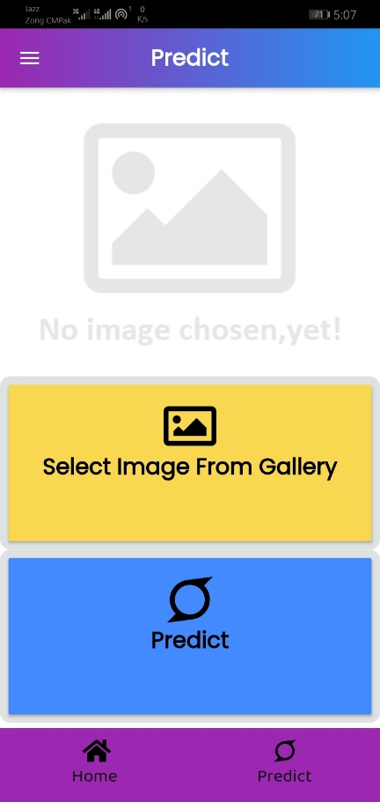

Figure 2.9: Symptoms Page Mobile App

Figure 2.10: Do's & Don’t Do's Page Mobile App

Figure 2.11: Main Page Mobile App

Figure 2.12: Positive Result Mobile App

Figure 2.13: Predict Page Mobile App

Figure 2.14: Splash Page Mobile App

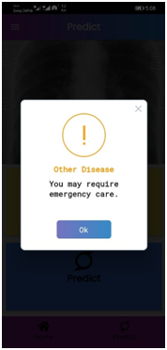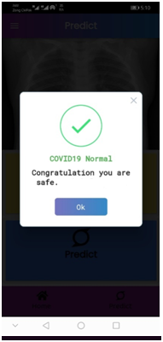

Figure 2.15: Other Disease Result Mobile App

Figure 2.16: Normal Result Mobile App

## Non-functional Requirements

Non-Functional requirements of the system are the attributes of system such as Reliability, Security, Maintainability, Performance, Usability and Scalability.

### Performance Requirements

* **Compatible to requirements**

Whole system features would be dependent on above functional requirements.

* **Compatibility:**

System will perform well, on all types of browsers, android and iOS platforms.

* **Response Time of system:**

Response time depends on actions.

* **Efficiency:**

System should transmit the data from customers to Admin with minimum delay. Calculation and Computation must be fast as maximum as possible

* **Supportability:**

The web application has used Simple HTML, CSS pattern for its menus making, icons. Also use flutter application for Android and iOS application to give support to android and iOS user

### Safety and Security Requirements

* **Security**

There will be no interfering to the dataset. Administrators of the system will have full right to check and train model.

* **Safety**

If user provides wrong X-RAY contain low picture size or low quality images then it can proceed to a wrong output result.

### Software Quality Attributes

* **GUI Design of system:**

Web, Android and iOS application have attractive and easy to use interface.

* **Availability:**

System must be available and work whenever required. 24/7 every time.

* **Maintainability:**

The application is to be designed so that it is easily maintained also it should allow incorporating new requirements in any module of system.

* **Easy to use:**

This web-application is very easy to use even a new user will feel familiar with this app.

# DESIGN SPECIFICATIONS

A design approach is a general philosophy that may or may not include a guide for specific methods. Some are to guide the overall goal of the design. Other approaches are to guide the tendencies of the designer. A combination of approaches may be used if they don’t conflict.

## Introduction

. In our software, a structured design approach has been used. Structured design approaches make a complete structure of the system that can be divided into different modules. Modules can be developed separately and then they can be integrated into a structure. All the modules interrelate with each other. This approach is based on the "divide and conquers" rule. The problem is divided into small problems. Each problem is solved individually. In the end, these solutions are linked into a hierarchy.

## Composite Viewpoint

* **Web Application**

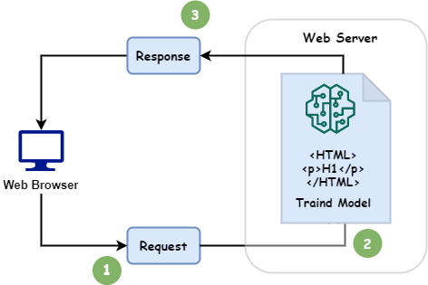

Figure 3.1: Package Diagram for Web Application

* **Mobile Application**

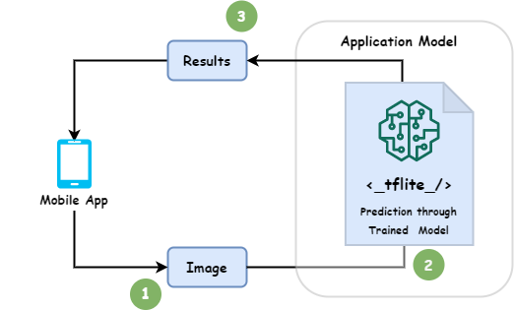

Figure 3.2: Package Diagram for Mobile Application

## Logical Viewpoint

* **Web Application**

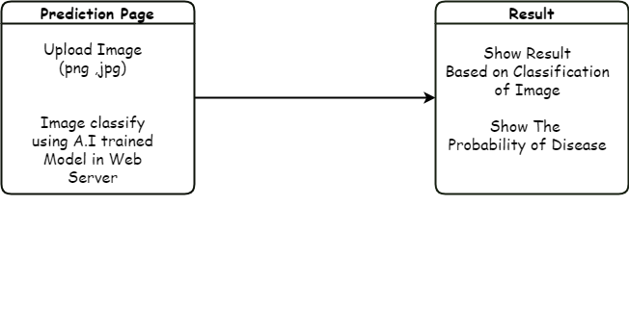

Figure 3.3: Class Diagram for Web Application

* **Mobile Application**

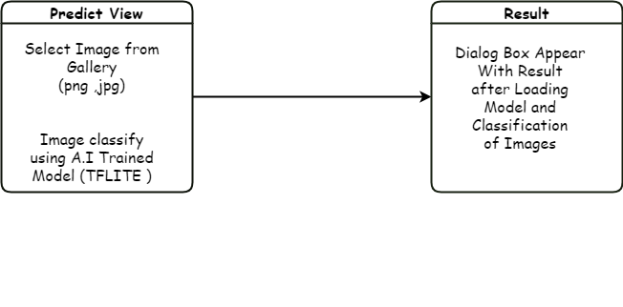

Figure 3.4: Class Diagram for Mobile Application

## Information Viewpoint

There is no Database of our project. So, there is no ERD. Interaction Viewpoint

## Interaction Viewpoint

* **Web Application**

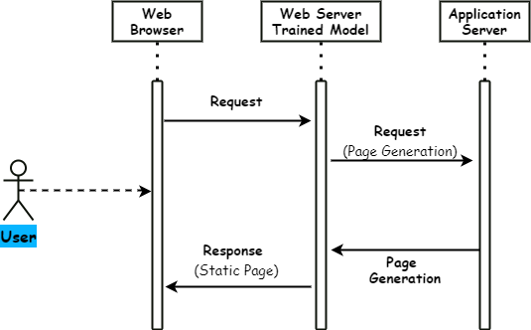

Figure 3.5: Sequence Diagram for Web Application

* **Mobile Application**

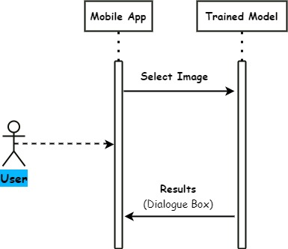

Figure 3.6: Sequence Diagram for Mobile Application

## State Dynamics Viewpoint

* **Web Application**

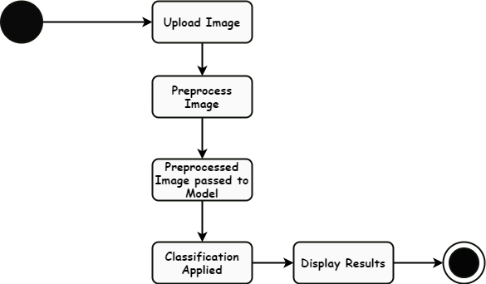

Figure 3.7: UML State Machine Diagram for Web Application

* **Mobile Application**

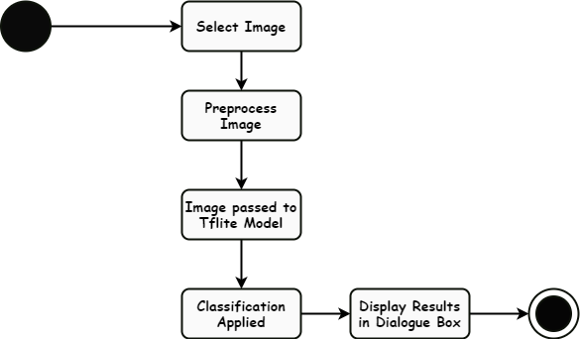

Figure 3.8: UML State Machine Diagram for Mobile Application

## Algorithmic Viewpoint

We have used Image Classification trained model to predict Covid Negative, Covid Positive and Other Disease. Whenever user select Image it preprocessing apply on it. After preprocessing image passed to the pre trained model. After that model applies computation on the Preprocessed Image and predicts result. The predicted results and probability of occurrence show to user that can be understandable by user easily.

* **Algorithm use for project is given below**

**Step 1:**

* Select Image

**Step 2:**

* Applying pre-processing on image and passed to Model

**Step 3:**

* Model applies computation on image
* Predict Results

**Step 4:**

* Show Results

# DEVELOPMENT AND TOOLS

This Chapter is all about the development strategies and Tools. Development tools are the tools like IDE used to develop a system or program. And we also discuss the Development techniques like algorithm and languages. Moreover, we also discuss the development plans for this system with Gantt chart. Also discuss the conclusion for this project and the future work strategy for this project.

## Introduction

In development and tools chapter we will discuss all the development strategies as well as tool that we used in our project. In this chapter we will explain our development plans, stakeholders of our project, tools, and technologies used in our project also include the conclusion and future work in the end of this chapter.

## Development Plan

This project is developed by team of two members.

1. **Muhammad Bilal**
2. **Mufassal Hussain**

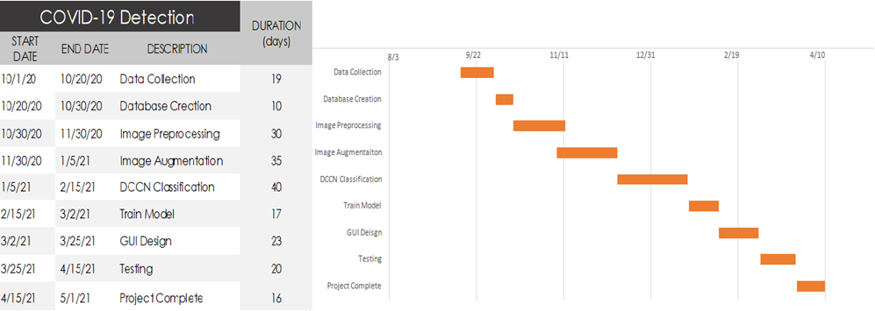

Figure 4.1: Gantt chart

## Development Tools

Table 4.1: Tools and Technologies for Proposed Project

|  |  |  |  |
| --- | --- | --- | --- |
| **Tools**  **And**  **Technologies** | **Tools** | **Version** | **Rationale** |
| Android studio | 4.1 | IDE |
| VS code | 1.55.2 | IDE |
| Jupyter notebook (Anaconda) | 6.4.0 | IDE |
| Flutter | 2.0 | SDK |
| MS Word | 2015 | Documentation |
| MS Power Point | 2015 | Presentation |
| **Technology** | **Version** | **Rationale** |
| Python | 3.8.6 | Programming Language |
| HTML | 5 | Web development |
| Flask | 1.0.2 | Web frame work |
| Dart | 2.0 | Programming language |

## Conclusion and Future Work/Extensions

We use CNN Algorithms to train our model to a dataset of preprocessed X-Ray images of Corona positive patients and the Normal persons X-Ray images after preprocessing. We use our trained model in HTML flask web to give it a GUI look. When we give the Model an X-Ray image it will perform preprocessing it use CNN Algorithm to classify whether it classified to Corona Positive or Negative. If it classified as Corona positive it shows report as positive and if it classified as Normal it shows report as negative

In future, we will test our project on large scale to test its accuracy. After this we will online our system for public use so that anyone can use our system to detect COVID-19 detection using chest X-RAY. We will also upload our android and iOS apps on Google play Store and iOS App Store. So, anyone can access our project and can benefit himself with the prediction.

# QUALITY ASSURANCE

Quality assurance is a means and practice of monitoring the software engineering processes and methods used in a project to ensure proper quality of the software. It may include ensuring conformance to standards or models.

## Introduction

In quality assurance phase which is mainly based on Test plan including testing strategies and types of testing applied to ensure the reliability and accuracy of the application to give the user a great and error free learning experience. Since satisfaction of end user is a first and foremost priority, thus to ensure it, a proper testing mechanism was devised and the results are tabulated in the form of test cases and to trace each test case against desired functional requirement a requirement traceability matrix have been devised which include test case ID against each and every functional requirement desired by user.

## Traceability Matrix

Table 5.1: Traceability Matrix

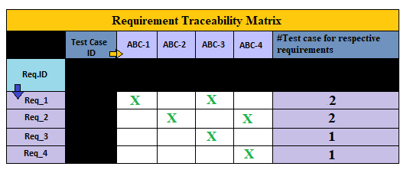

## Test Plan

Test plan contains the testing mechanism and the entire tests that have been conducted to test the application. This section should include all the test cases conducted for quality assurance of each function requirement.

Table 5.2: Test case for web Application start up

|  |  |
| --- | --- |
| Test ID | ABC-1 |
| Test name | Application startup |
| Date of test | 04/06/2021 |
| Name of application | CDUCX |
| Description | Home screen will be displayed where user will be able to read the basic knowledge about this app. |
| Input | Open web Application |
| Expected output | Home screen displayed |
| Actual output | Home screen displayed |
| Test Role (Actor) | Muhammad Bilal, Mufassal Hussain. |
| Test verified by | Sir, Jawad Rafique |

Table 5.3: Test case for Covid Prediction through Website.

|  |  |
| --- | --- |
| Test ID | ABC-2 |
| Test name | Prediction test |
| Date of test | 04/06/2021 |
| Name of application | CDUCX |
| Description | Covid detection page will be displayed where user will select X-Ray Image for prediction and provide their personal info and Result will be displayed as in categories of COVID Positive, COVID Negative and Other disease. |
| Input | Open Covid detection web page and upload X-Ray Image with personal info and tap detect button, |
| Expected output | Result will be displayed as in categories of COVID Positive, COVID Negative and Other disease |
| Actual output | Result is displayed as in categories of COVID Positive, COVID Negative and Other disease |
| Test Role (Actor) | Muhammad Bilal, Mufassal Hussain. |
| Test verified by | Sir, Jawad Rafique |

Table 5.4: Test case for Mobile Application start up

|  |  |
| --- | --- |
| Test ID | ABC-3 |
| Test name | Application startup |
| Date of test | 04/06/2021 |
| Name of application | CDUCX |
| Description | Home screen will be displayed where user will be able to read the basic knowledge about this app. |
| Input | Tap on CDUCX app icon. |
| Expected output | Home screen displayed |
| Actual output | Home screen displayed |
| Test Role (Actor) | Muhammad Bilal, Mufassal Hussain. |
| Test verified by | Sir, Jawad Rafique |

Table 5.5: Test case for Covid Prediction through Mobile Application

|  |  |
| --- | --- |
| Test ID | ABC-4 |
| Test name | Prediction test |
| Date of test | 04/06/2021 |
| Name of application | CODUCX |
| Description | prediction page will be displayed where user will select X-Ray Image for prediction and Result will be displayed as in categories of COVID Positive, COVID Negative and Other disease. |
| Input | Open CDUCX app and upload X-Ray Image and tap predict button, |
| Expected output | Result will be displayed as in categories of COVID Positive, COVID Negative and Other disease |
| Actual output | Result is displayed as in categories of COVID Positive, COVID Negative and Other disease |
| Test Role (Actor) | Muhammad Bilal, Mufassal Hussain. |
| Test verified by | Sir, Jawad Rafique |

# USER MANUAL

A user manual is a technical communication document intended to give assistance to people on how to use a product/System or App. A good user manual assists users on how to use a product safely and effectively. In this chapter we will discuss all the aspects of this app for user to use it effectively and correctly to avoid all kind of problems or any kind of wrong prediction.

## Introduction

In this chapter, we will discuss all the information, techniques and knowledge that a user must know before using this system. We will discuss all the aspects like hardware/software requirements for this system, Installation process and the operation guide for this system to make it easy for user to use this system.

## Hardware/Software Requirements for the System

1. **Web Application:**

**Hardware requirement:**

* A computer device (Mobile, Tablet, PC, Laptop or any other) with internet connection.

**Software requirement:**

* Browser
* Internet connection

1. **Mobile Application:**

**Hardware requirement:**

* A Mobile (Android or iOS).

**Software requirement:**

* Android > version 4.0 or iOS >= version iOS-13

## Installation guide for Application

1. **Web:**

* Open Browser in your device (Internet access).
* Go to Covid-19 detection (CDUCX) web link.

1. **Mobile Application:**

* Open your device app store (for android “Play store” and for iOS “App store”).
* Search Covid-19 Detection app (CDUCX).
* Click on install button

## Operating Manual

1. **Web:**

* Open Website in Browser.
* Go to “Covid-Detection” page.
* Enter your personal details in form.
* Upload your clear Chest X-Ray image (jpg, png or jpeg).
* Click on “Detect” Button
* The result will show within 5 seconds as Covid Positive, Covid Negative or Other disease in alert box.

1. **Mobile Application:**

* Open “CDUCX” app in your mobile.
* Navigate to “predict” page through App drawer or footer navigation bar.
* Click on “Select Image from Gallery”.
* Upload X-Ray image (jpg, png or jpeg) by selecting through phone gallery.
* Once image is uploaded click on “predict” button.
* The result will show within 2 seconds as Covid Positive, Covid Negative or Other disease in alert box.